**Author information**

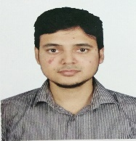

Dr. Md Iftekharul Mobin, Assistant Professor, Computer Science, D219,

American International University-Bangladesh (AIUB)

[iftekhar.mobin@aiub.edu](mailto:iftekhar.mobin@aiub.edu), ORCID ID 0000-0002-3065-2486

D Building, 408/1, Kuratoli, Khilkhet, Dhaka 1229, Bangladesh

Dr. Md Iftekharul Mobin, (Member, IEEE), Assistant Professor of Faculty of Science and Technology at American International University-Bangladesh (AIUB). Dr. Mobin's scholarly pursuits are anchored in a diverse range of research domains, including Natural Language Processing (NLP), time-series prediction, health informatics, Internet of Things (IoT), and Image processing. Earned his Ph.D. from Queen Mary University of London, B.Sc. obtained from the Islamic University of Technology (IUT). He achieved Queen Mary scholarship and the ImpactQM scholarship, in acknowledgment of his contributions to industry-academia partnerships. Dr. Mobin's research endeavors have received support from Bangladesh's Ministry of Information and Communication Technology (ICT). He served as a software engineer in the United Kingdom, Japan, and Bangladesh for several years. This dual exposure to both academic and industry settings has enriched his perspectives and insights of industry academia collaboration and implications. He has served as a program committee member of international conferences, editor, and reviewer for various conferences and journals worldwide. For inquiries can be contacted at iftekhar.mobin@aiub.edu.

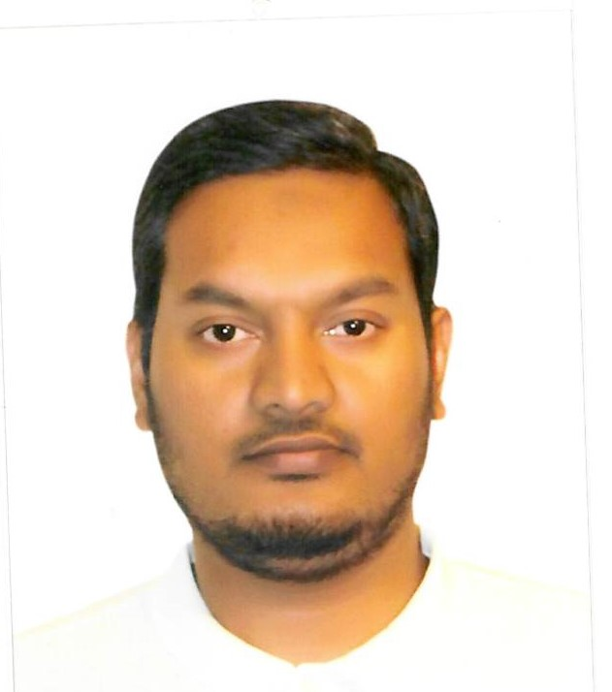

[suaibakhter@subu.edu.tr](mailto:suaibakhter@subu.edu.tr>)

A. F. M. Suaib Akhter, Department of Computer Engineering, Sakarya University of Applied Sciences, Sakarya, Serdivan, Turkey.   
  
A. F. M. Suaib Akhter (Member, IEEE) received the Ph.D. degree from the Department of Computer and Information Engineering, Sakarya University, Turkey, in 2021. He is currently working as a Lecturer with the Sakarya University of Applied Sciences. He is also involved in several projects related to distributed systems and the Internet of Things (IoT). His research interests include blockchain technology, the IoT, wireless communications, vehicular ad hoc networks, intelligent vehicles, network security, distributed systems, and machine learning. He is also serving as an Associate Editor for the Journal of Cyber Security Technology (Taylor & Francis) and a guest editor for many special issues of different journals.

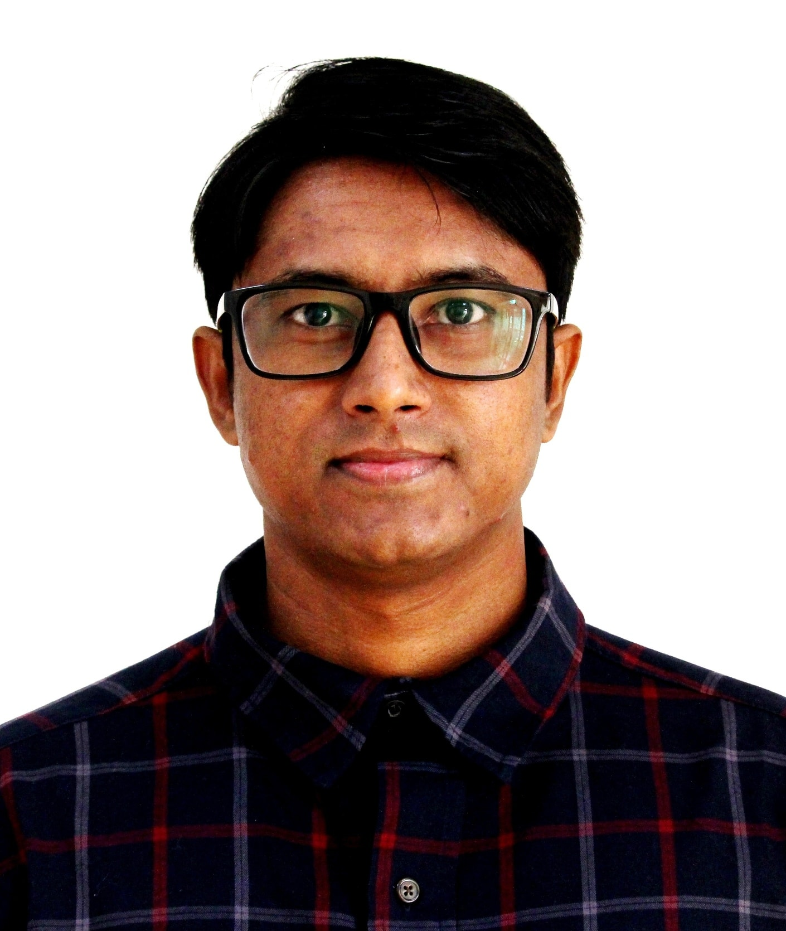

Dr. S. M. HASAN MAHMUD, Assistant Professor, Computer Science, D217,

American International University-Bangladesh (AIUB)

[hasan.swe@aiub.edu](mailto:hasan.swe@aiub.edu), ORCID ID 0000-0002-6828-3559

D Building, 408/1, Kuratoli, Khilkhet, Dhaka 1229, Bangladesh

Dr. Mahmud is currently serving as an Assistant Professor in the Computer Science Department at American International University-Bangladesh (AIUB) in Dhaka, Bangladesh. His research interests primarily include machine learning and health informatics using Big Data analytics technologies. He has authored or co-authored approximately 60 journal and conference papers (Total IF: 150). Dr. Mahmud has served as a program committee member, track chair, session chair, editor, and reviewer for various conferences and journals worldwide. He has received several awards, including the Best Paper Award and the 2nd position in the Best Academic and Research Award-UESTC. Furthermore, he has actively participated in organizing international conferences. Dr. Mahmud currently holds the position of Director at the Centre for Advanced Machine Learning and Applications, where researchers and professors collaborate from the USA, Australia, Sweden, China, and Bangladesh. Email: hasan.swe@aiub.edu

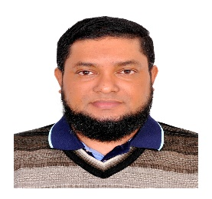

Md. Golam Rabiul Alam, PhD, Professor

Kha 224 Bir Uttam Rafiqul Islam Avenue, Merul Badda, Dhaka 1212

[rabiul.alam@bracu.ac.bd](mailto:rabiul.alam@bracu.ac.bd)

ORCID ID: 0000-0002-9054-7557

Md. Golam Rabiul Alam (Member, IEEE) is a Professor of Computer Science and Engineering Department of BRAC University. He received Ph.D. in Computer Engineering from Kyung Hee University, South Korea in 2017. He served as a Post-doctoral researcher in Computer Science and Engineering Department, Kyung Hee University, Korea from March 2017 to February 2018. Dr. Rabiul Alam received B.S. and M.S. degrees in Computer Science and Engineering, and Information Technology from Khulna University and University of Dhaka respectively.   Dr. Rabiul Alam has published more than 200 research articles in reputed journals, and conference proceedings. His research interests include Affective computing, Ambient intelligence system, Health informatics, Healthcare-IoT networks, and Edge computing.  He is a member of the IEEE Computer Society, Consumer Electronics Society, and Industrial Electronics Society and received several best paper awards at national and international research conferences.

**Conflict of Interest – None**

**There is hereby declare that there is not any** Conflict of Interest.